Practical 4
https://youtu.be/x5kWT7JJH4I?si=Eg2XJWt7bkzLcHH6
Address Table:-
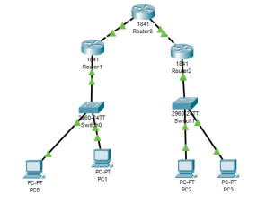

Device | Interface | IP
PC0 |  | 192.168.1.2/192.168.1.1
PC1 |  | 192.168.1.3/192.168.1.1
PC2 |  | 192.168.2.2/192.168.2.1
PC3 |  | 192.168.2.3/192.168.2.1
R1 | F0/0 | 192.168.1.1
 | F0/1 | 10.0.0.1
R2 | F0/0 | 10.0.0.2
 | F0/1 | 20.0.0.1
R3 | F0/0 | 20.0.0.2
 | F0/1 | 192.168.2.1

Int tunnel 1
Ip address 50.50.50.1 255.255.255.0
Int tunnel 1
Ip address 50.50.50.2 255.255.255.0
Show ip int br
Implement VTP VTP Server
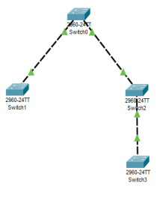
VTP Client VTP Transparent

VTP Client
Switch 1
Int f0/1
Switchport mode trunk
Int f0/2
Switchport mode trunk
Show vtp status
Vtp mode server
Vtp domain VTPServer
Show vtp status
Vlan 10
Name department
Switch 2
Vtp mode client
Show vtp status
Show vlan
Switch 3
Vtp mode transparent
Show vtp status
Switch 4
Vtp mode client
Show vtp status
Implement NAT
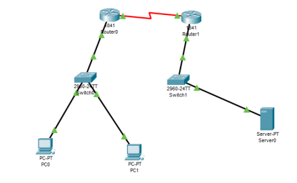Address Table
Device | Interface | Address
PC0 | 192.168.1.2/192.168.1.1
PC1 | 192.168.1.3/192.168.1.1
R0 | 192.168.1.1 | F0/1
 | 10.0.0.1 | S0/0/0
R1 | 172.16.1.1 | F0/1

 | 10.0.0.2 | S0/0/0
Server | 172.16.1.2/172.16.1.1

R1:
Router(config-if)#exit
Router(config)#interface FastEthernet0/0
Router(config-if)#ip nat inside
Router(config-if)#eiexit
Router(config)#
Router(config)#interface FastEthernet0/0
Router(config-if)#
Router(config-if)#exit
Router(config)#interface Serial0/0/0
Router(config-if)#ip nat outside
Router(config-if)#exit
Router(config)#ip nat inside source static 192.168.1.2 10.0.0.1
Router(config)#ip nat inside source static 192.168.1.3
ip route 0.0.0.0 0.0.0.0ip route 0.0.0.0 0.0.0.0
% Incomplete command.
Router(config)#end
Router#
%SYS-5-CONFIG_I: Configured from console by console
Router#show ip nat tr
Set RIP routing protocol

